Field Level Auditing in Pega

**Field-level auditing** enables you to monitor changes to important data values in your cases..

We can use the pega provided OOTB field level audit recording feature, which can be reusable.

Field level auditing allows you to keep an eye on the sensitive data values.

Audit level changes will be recorded in the FLAudit table and History Tables.

How to enable the field level audit

Go to settings tab of case type and go to Auditing

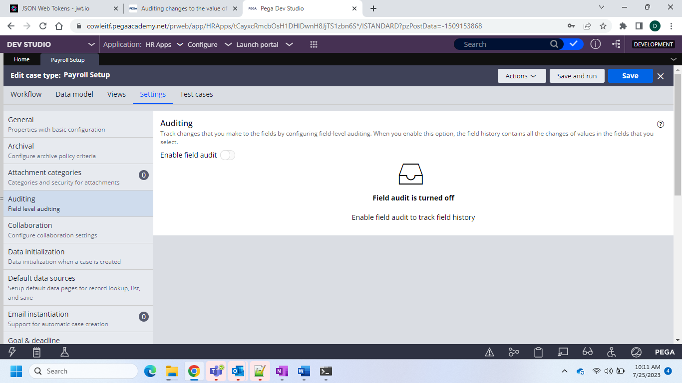

By enabling the field level audit the following rules would be created in the unlocked ruleset version.

Declare Trigger – pyFieldLevelAuditing – it is responsible to execute the auditing logic each time when “Data Save” is performed on the work object

“pxfieldlevelauditing” activity when called this rule..

And activity and the declare trigger is

And now these are responsible for the execution of the field history

We can see the details

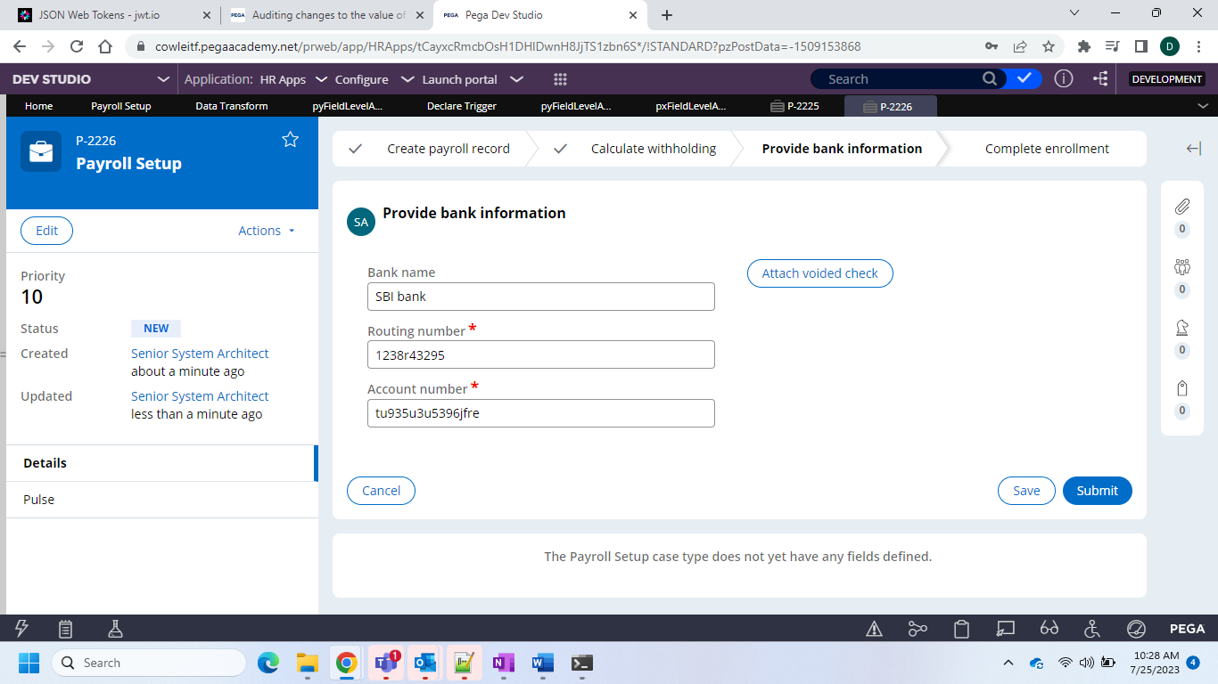

And now you can check in the history of the field history tab from View Actions

